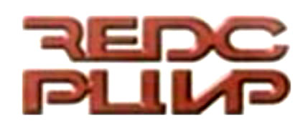
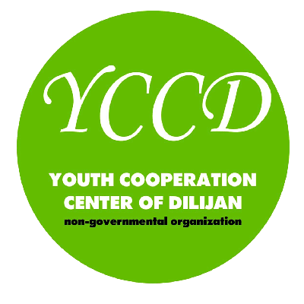

CALL FOR PARTNERS

M3 - Management, Marketing and Money

for NGOs and Youth in EAST and WEST

International Training Course in
Gyumri, Armenia • January 15-23, 2011
24 August, 2010
Dear friends,

the Regional Economic Development Center REDC (Bulgaria) in co-operation with the Youth Cooperation Center of Dilijan YCCD (Armenia) is planning on providing an international 7-day-training course on management and marketing for NGOs working with youth and international youth mobility. For this, we are looking for approx. 20 international partner organizations from the EU and from Eastern European and Caucasian Countries. Being a partner organization entitles you to nominate 1 to 2 participants for the training course.

MAIN ISSUES TACKLED

EAST - WEST
- Realities of youth and NGOs in East and West
- Motivation for and specificities in East-West co-operation

Strategic Management
- Mission Statement, Stakeholder Analysis
- Key Performance Indicators, Recursive Management
- Various techniques for identifying and assessing strategies and future developments

Organisational Management
- Human Resources Management (incl. Self Management)
- Communication and Decision Making
- Information and Knowledge Management

Marketing
- Market Analysis and Product/Client Portfolios
- Public Relations (PR) and Promotion

Financial Management
- Budgeting and Controlling
- Fundraising
- Accounting and Reporting

Youth in Action and future partnerships/projects

AIM, APPROACH AND OUTCOME
In this international training course, we will deal with how to ensure quality, stability, sustainability and visibility in our projects and programmes. Many times drawing from approaches in the sector of private economy and adapting them to the necessities and realities of NGOs, we will better know our „products“, our potential clients and how to reach them, our supporters and partners, the environment/market we operate within, and how we can position ourselves in this market and raise the visibility and appreciation of our work.

We will analyze our own structures, our working procedures/processes (e.g. related to decision making, information and implementation), and our planning and controlling mechanisms. We will introduce management tools that can help ensure quality and sustainability and thus allow long-term planning and strategic development. And last but not least we will deal with some important aspects of financial management such as fundraising, accounting and controlling.
Frontal inputs will provide the theoretical background and the introduction of practical tools, which will then be immediately tried out in the framework of exercises, simulations, and – most importantly - with reference to the cases of our own organizations and our respective activities. A minor part of the training will also be dedicated to the Youth in Action (YiA) programme, to the fostering of future projects, to the reflection on the realities of youth and NGOs in East and West, and to highlighting specificities in youth mobility projects embracing East-West co-operation.

CONDITIONS
The training is scheduled for Jan 15th to 23rd 2011 and will be hosted in Gyumri, Armenia!
Financial support is sought for under the European Commission’s “Youth in Action”-programme granting scheme. If approved, all costs will be covered except for 30% of the international travel costs and a participation fee of EUR 30. Organisations from all 27 EU member countries plus Liechtenstein, Norway, Iceland and Turkey, as well as all EECA countries (Russia, Belarus, Ukraine, Moldova, Armenia, Azerbaijan and Georgia) are eligible to take part. The training course will be held in English.

NEXT STEPS
To be a partner organization in this activity, please do the following:
- Fill in the attached form (called “part III”), sign it in blue ink, put your official stamp on it and send it by fax and e-mail (scan copy as .pdf or .doc or .jpg, we need the signature and the stamp) and regular mail back to us (address indicated below)
- Indicate your estimated travel costs for a return trip from your home town to Yerevan (or Gyumri). Include visa costs if applicable (All EU Citizens need a Visa).
- To help us in the selection process and to fine-tune the programme, please add an additional document describing your motivation to join this training course as a partner organization (what are your training needs in the area of management and marketing? Where do you face challenges? What would you expect to benefit from the training course? What could you contribute?).
Also, please forward this call to any partner, network or organization you deem possibly interested.
Please make sure we receive all these documents before Sunday, August 29th at the following address:

Regional Economic Development Center REDC
hands of Julietta Nikolova
3а Dimitar Pehlivanov str., Sliven, Bulgaria

Tel/fax: +35944623747;
E- mail: redc_sliven@abv.bg and CC to: narazak2002@yahoo.com
URD: www.redc-sliven.org

We are looking forward to your answers...

…best regards from Sliven in Bulgary and Gyumri in Armenia!

